SECURED VISA®
This card provides an excellent opportunity for someone starting a credit history or for someone who has been turned down for a credit card. If you need to improve or re-establish your credit history,¹ here's a great way to begin that process.
An Associated Bank Secured Visa® Credit Card can be used like any other credit card including online account access, EMV chip technology and a host of other great benefits.²
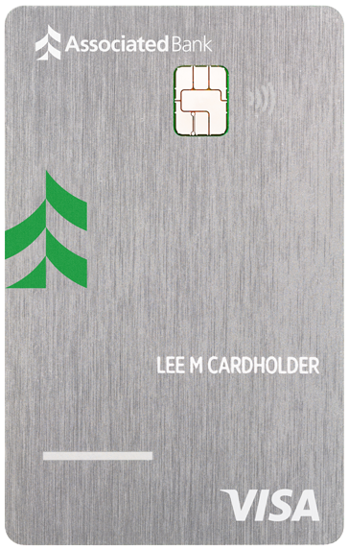

Earn rewards with a Max Cash Secured Visa®
Earn rewards
5% cash back on first $2,000 of combined quarterly purchases in two categories like: TV, internet & streaming services, home utilities, cell phone providers and more!³
2% unlimited cash back on your choice of one everyday like gas stations and EV charging stations or grocery stores.*
*Excludes discount stores/supercenters and wholesale clubs.
1% unlimited cash back on all other eligible purchases.
Redeem cash back for a statement credit, rewards card or a deposit to a qualifying account.
Enjoy convenience

Year-end Summary—Receive an online detailed summary of your spending during the year for convenient budget analysis and financial planning.

Free Credit Score⁴
Security you can trust

Emergency Card Replacement & Cash Disbursement—Provides worldwide, 24-hour assistance with lost and stolen card reporting, emergency card replacement and emergency cash advance.

Lost/Stolen Card Reporting—Visa will forward reports of lost or stolen cards to the appropriate card issuers.

Verified by Visa—Protects your card online with a personal password.

Zero Liability/Fraud Protection—Zero liability from fraud and protection from unauthorized use of your card or account information.⁵

Contactless—Tap your credit card anywhere you see the contactless symbol

EMV smart chip technology—for added security.
Late payments or going over the credit limit may damage your credit history. Your credit limit will be equal to the amount of your security deposit. (1382)
- Certain limitations and restrictions may apply. (1284)
- Max Cash Preferred Card: Cardmember must initially enroll into categories of their choice, or all Net Purchases will earn no more than 1% cash back. Categories are subject to change. You will earn 5% cash back (1% base & 4% bonus) on your first $2,000 in combined Net Purchases each calendar quarter in your two chosen 5% categories and unlimited cash back in your one chosen 2% (1% base & 1% bonus) category. Purchases in the following everyday categories: Grocery Store/Supermarket and Gas Station/EV Charging Stations at Wholesale clubs, discount stores/supercenters such as Target and Walmart will only earn 1%. All other Net Purchases earn 1% cash back. Cash rewards can be redeemed as a deposit to a checking or savings account with this Financial Institution only, which will be deposited within 7 business days, or as a statement credit to your credit card account within 1-2 statement billing cycles, or as a Rewards Card. Cash back minimum redemption amounts and redemption values may vary and are subject to change without notice. Cash rewards do not expire as long as the account remains active. If there is no reward, purchase, or balance activity on your account for 12 statement cycles, your cash rewards balance will expire. (1311)
- Free credit score access, Alerts and Score Simulator through TransUnion’s CreditView® Dashboard are available to Elan Online Access customers only. Alerts require a TransUnion database match. It is possible that some enrolled members may not qualify for the Alert functionality. Free credit score access is not available in the Mobile App. The free VantageScore® credit score from TransUnion® is for educational purposes only and not used by Elan Financial Services to make credit decisions. (1310)
- Elan Financial Services provides Zero Fraud Liability for unauthorized transactions. Cardmember must notify Elan Financial Services promptly of any unauthorized use. Certain conditions and limitations may apply. (1286)
- Subject to credit approval. The creditor and issuer of these cards is Elan Financial Services, pursuant to a license from Visa U.S.A. Inc. (1056)
- The Elan Rewards Program is subject to change. Rewards are earned on eligible Net Purchases. Net Purchases are purchases minus credits and returns. Not all transactions are considered to be Purchases and eligible to earn rewards, such as transactions posting as Convenience Checks; Balance Transfers; Advances (including ATM withdrawals, wire transfers, traveler's checks, money orders, foreign cash transactions, betting transactions, and lottery tickets); interest charges and fees; credit insurance premiums; and transactions to (i) fund certain prepaid card products, (ii) buy currency from the U.S. Mint, or (iii) buy cash convertible items. Upon approval, see your Cardmember Agreement for details. Account must be open and in good standing (not past due or overlimit) to earn and redeem rewards and benefits. Subject to applicable law, you may not redeem rewards, and you will immediately lose all of your rewards, if your Account is closed to future transactions (including, but not limited to, due to Program misuse, failure to pay, bankruptcy, or death). Rewards expire 5 years from when they are earned, refer to your Program Rules for full details. (1288)
- Visa and the Visa logo are registered trademarks of Visa International Service Association. (1115)

